OUTPUT: P1
Create Table

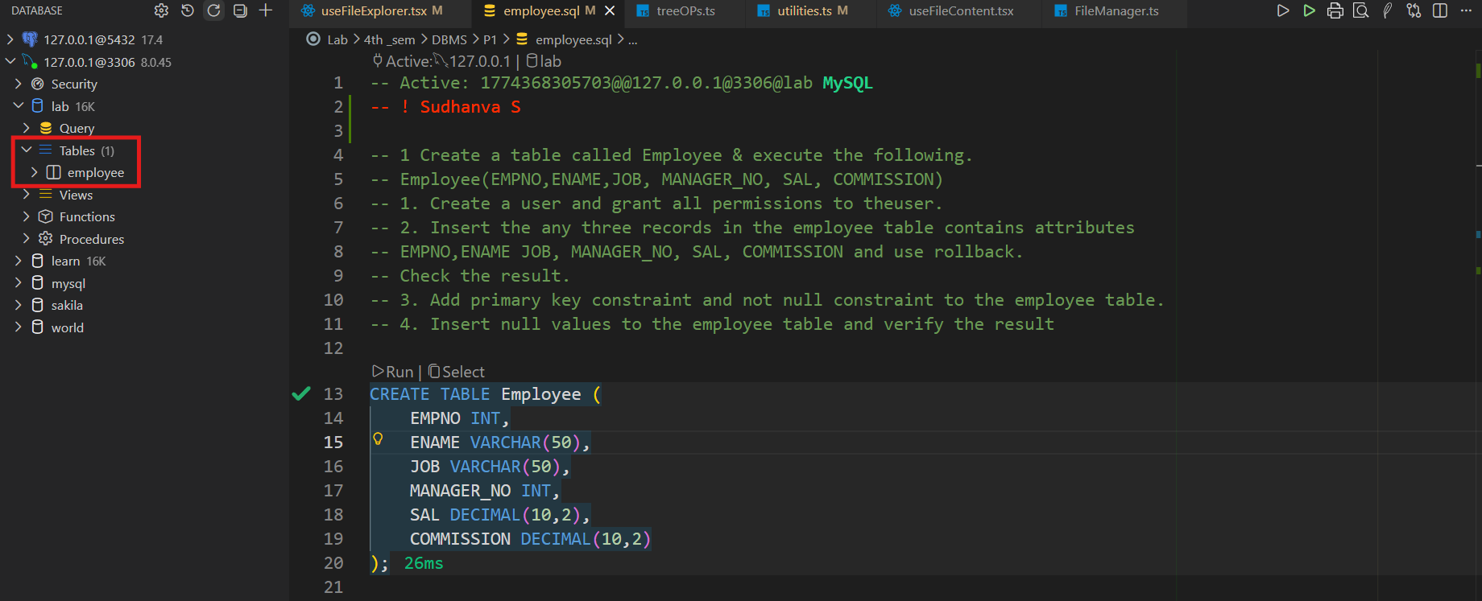

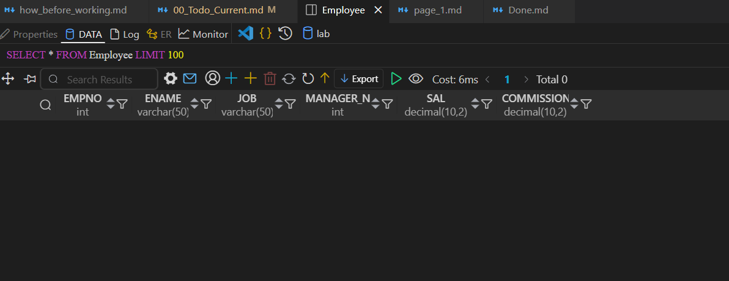

Create User & Grant Permissions
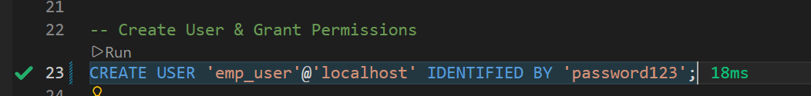
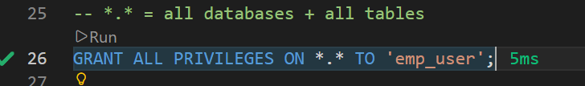
Insert Records + Roll Back
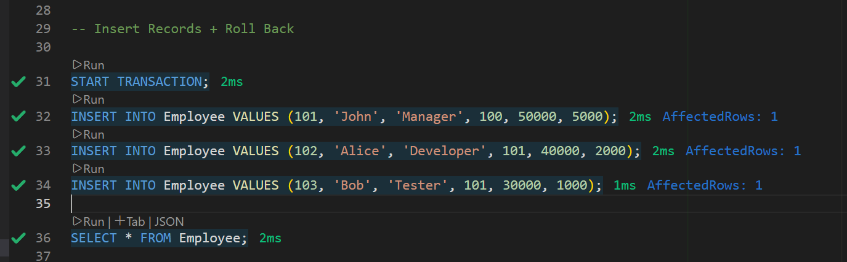

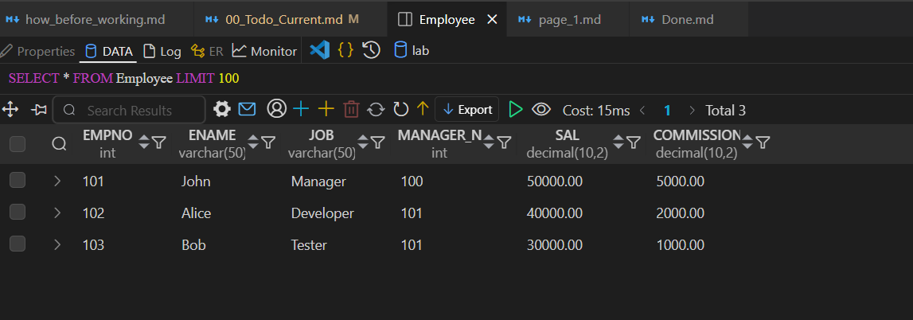

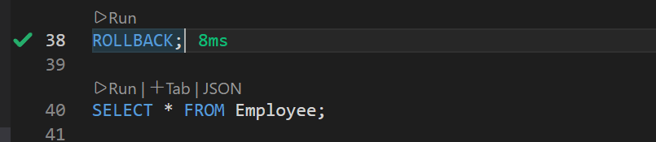


ADD CONSTRAINTS
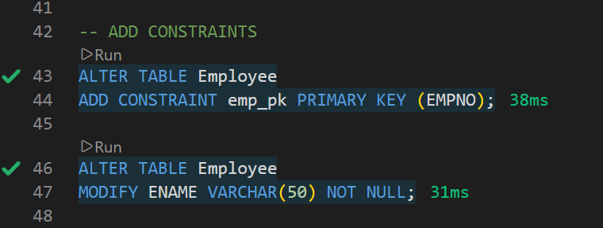

Insert NULL Values (Test Constraints)

